**Practices for Lesson 13: Siebel Productivity Tools**

Practices for Lesson 3

Overview

In these practices, you will explore on the Workspaces with Siebel WebTools and Siebel Apps.

**Practice 13-1: Setting up WebTools and managing Parallel Development**

**Overview:**

In this practice we will explore on workspaces with Siebel WebTools and Siebel Apps. For exploring this objective, you are required to have the below URLs read

App URL 🡪 Accessed via 4430/siebel/app/application-name/enu

Webtools URL 🡪 Accessed via 4430/siebel/app/webtools

Assumptions

You should have completed the Practices of Lesson 12.

Tasks

**Examine the structure**

1. Access WebTools link. Enter Username and Password, click **Login**.

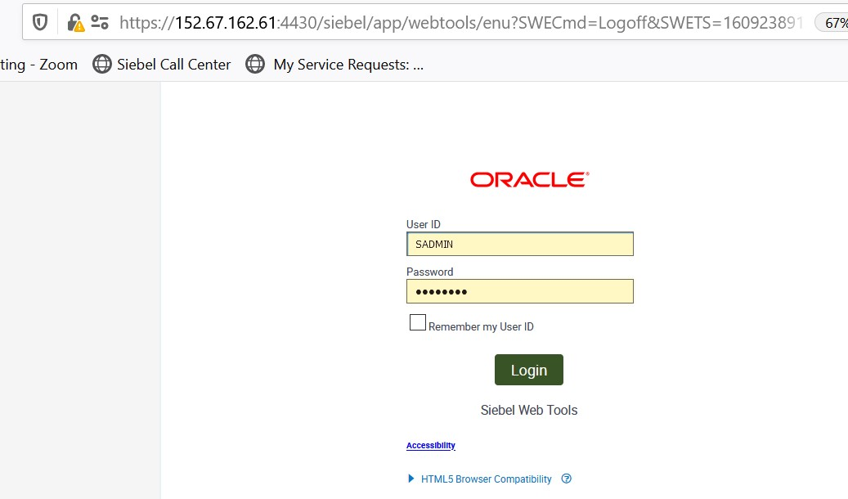

1. Click on the **Cube icon** in the top tool bar (workspace Icon).

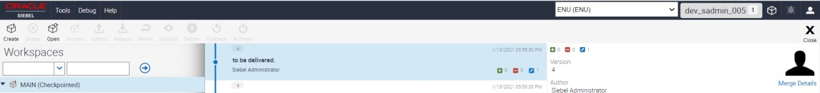

1. Click **Create** to generate workspace. Edit the details and click **Create WorkSpace** as shown below.

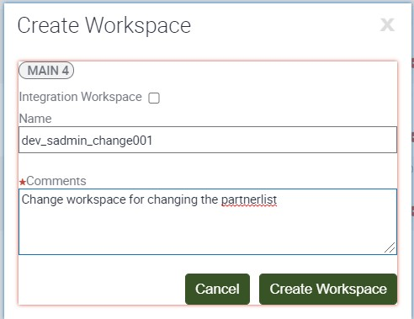

1. Make sure the profile addressed is as shown below in workspace.



1. Open app URL. Go to Account, then to Account List. Click on **Account**, drill down and choose **Profile** in the second level menu. Copy the name of the applet with the profile view and paste it in the notepad.

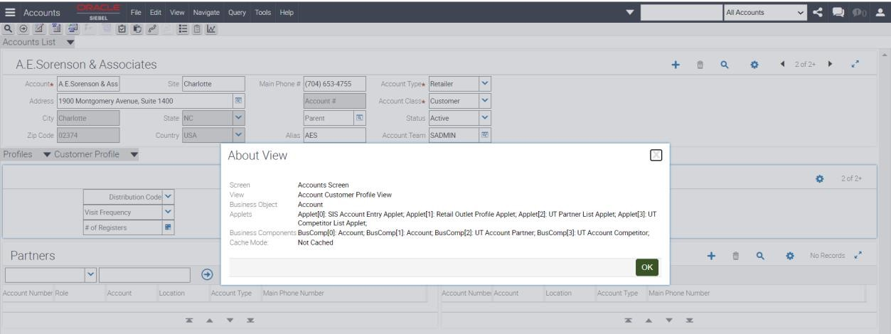

1. Now open the Siebel tools window back. Visit the view and filter for the view performed in Step 5.

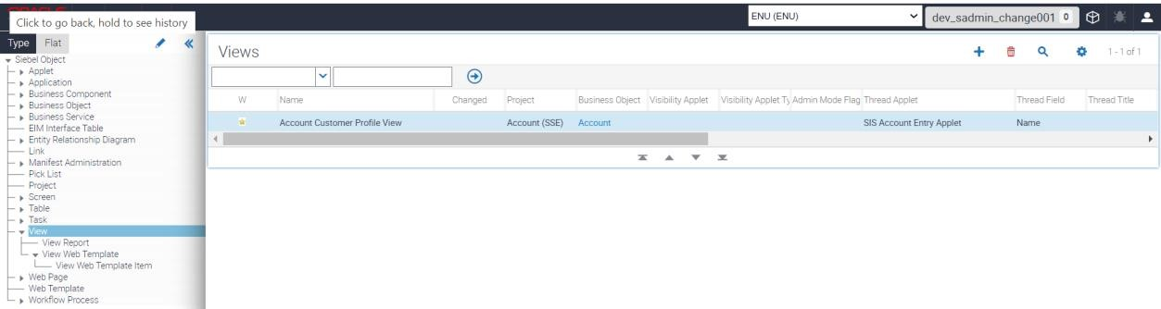

1. In the object explorer **View web Template**, filter for View Web Template



1. Filter for View Web Template item.

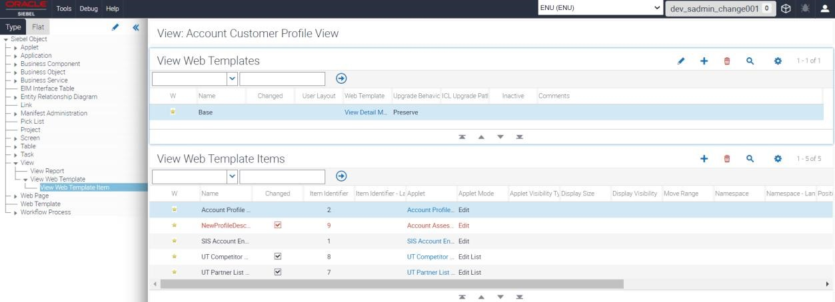

1. Edit theUT Competitor Item numberas **7** and Mode as **Base**. Edit the UT Partner List Item number as **8** and change Mode as **Base**.

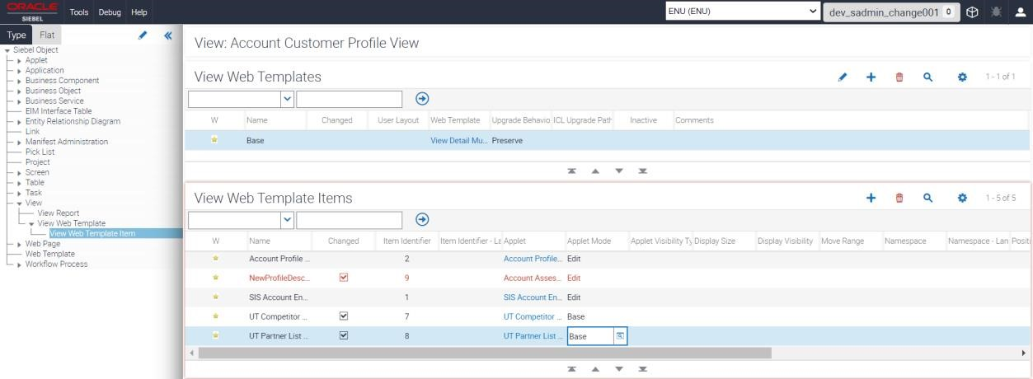

1. Click the Settings Icon and **Save** record.
2. Now click the workspace icon in the **Global toolbar**. Observe the status of the workspace. Click on **workspace name**.

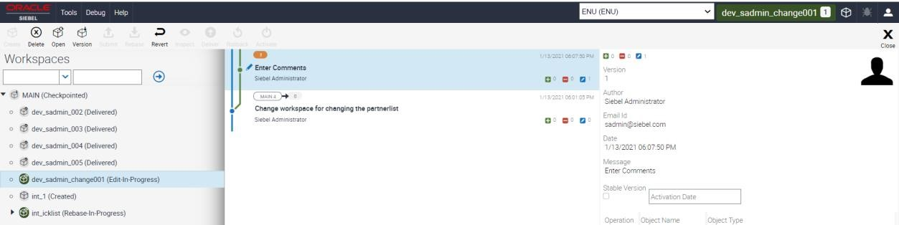

1. Click **version** to set up the version as below.

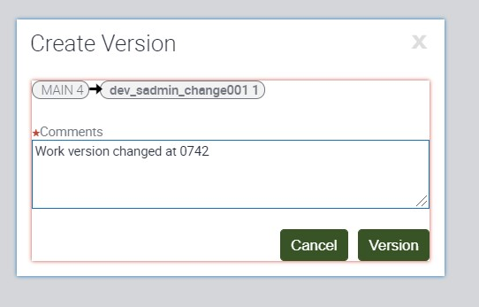

1. You will see the version changed.

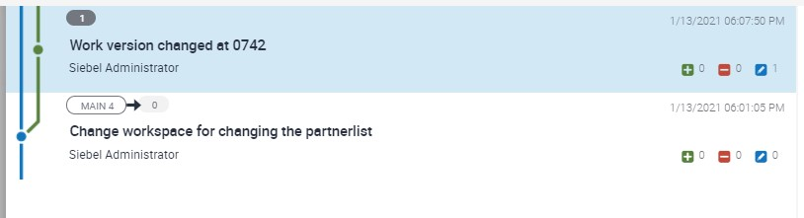

1. Click **Submit** for the administrator.

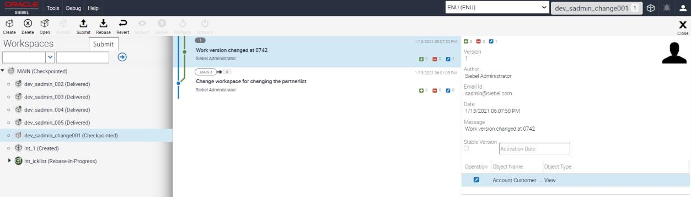

1. Submit the change to Administrator for review. Click **Submit**. After submitting, click **Deliver**.

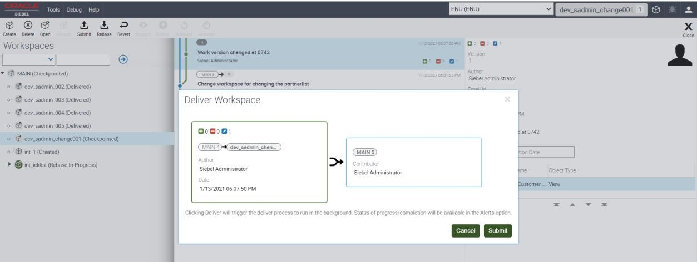

1. Click **Deliver** with Comments as shown below.

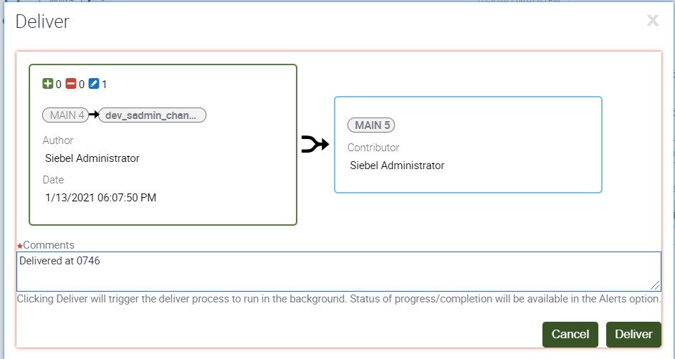

1. Logout from the Siebel apps url. Login again into Siebel apps url (as given in step 1)

You can Visit **Account** – **Account List** – **Profile**.

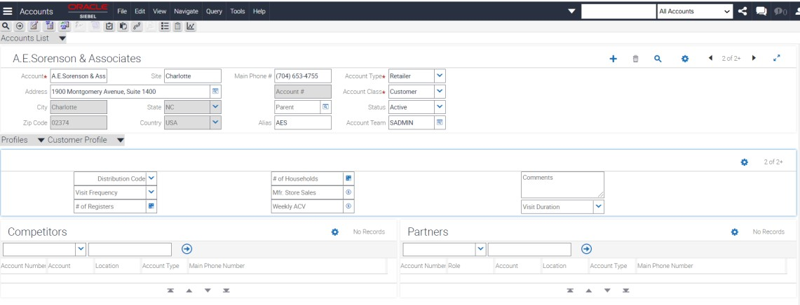

1. Now Let us restore back to old state. Go to **Siebel webtools URL** as mentioned in previous steps – go to the work space created. Click **Open**.
2. Click the web page template. You can see that you will not be able to edit any of the items as the workspace is delivered.

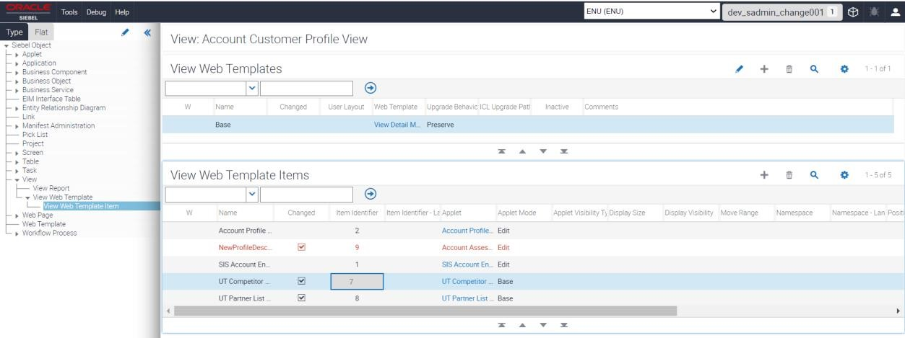

1. Click **Create** **new** **workspace** from clicking **workspace icon**. Provide the workspace name and comments as shown below and click **Create Workspace**.

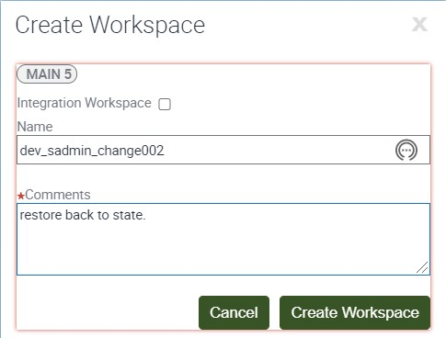

1. Change the **UT Partner and Customer numbers** back to original values. Modify the Control to **Edit List** for both as shown below. Click **Save Record.**

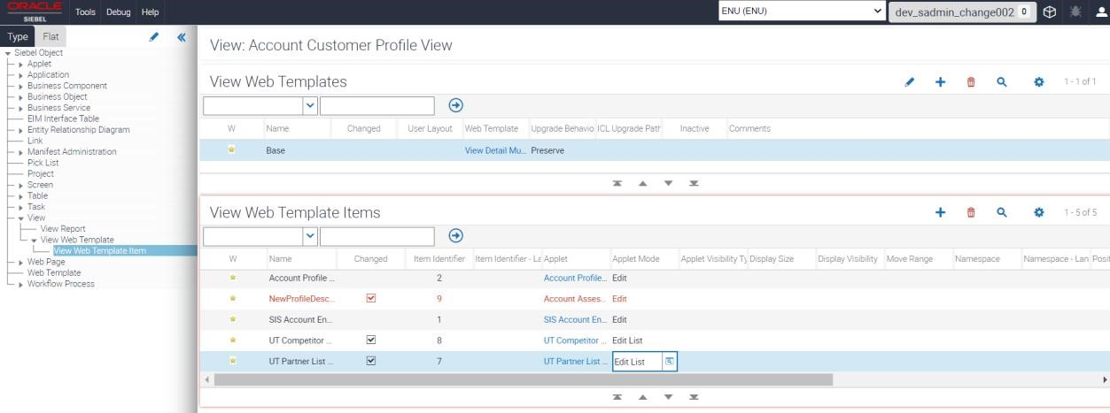

1. Click on workspace **cube** back to original. Click **version** for the revision to be submitted.

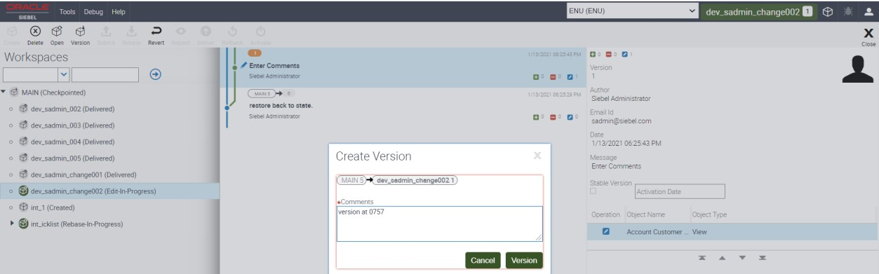

1. Click **Submit** for it to get delivered.



1. Click **Deliver** for it to get released.

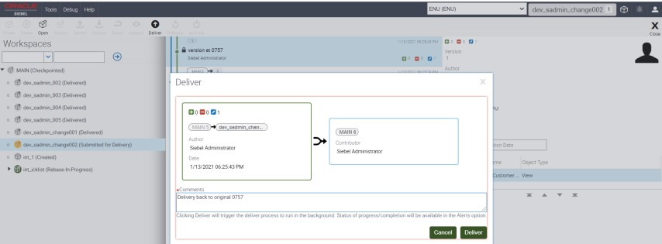

1. Now, verify the status for delivery.

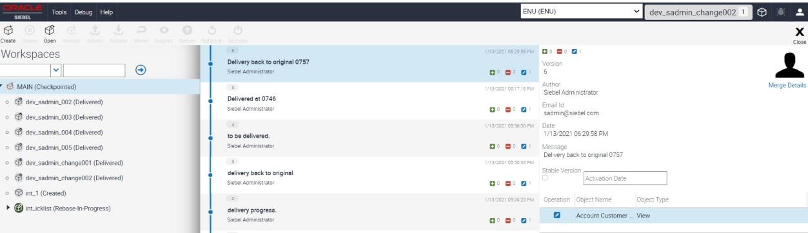

1. Logout and login from Siebel Apps. From Site map, visit **Account -Account List – Profile – Customer Profile**. You will see the changes reflected.

